CBB110213 李明發 影像處理導論 期末考繳交

第一題:

RGB MODEL:

import numpy as np

import cv2

def RGB_model(f,channel):

if channel == 1:

return f[:,:,2]

elif channel == 2:

return f[:,:,1]

else:

return f[:,:,0]

def main():

img = cv2.imread("Pepper.bmp")

R = RGB_model(img,1)

G = RGB_model(img,2)

B = RGB_model(img,3)

cv2.imshow("Original Image",img)

cv2.imshow("Red",R)

cv2.imshow("Green",G)

cv2.imshow("Blue",B)

cv2.waitKey(0)

main()

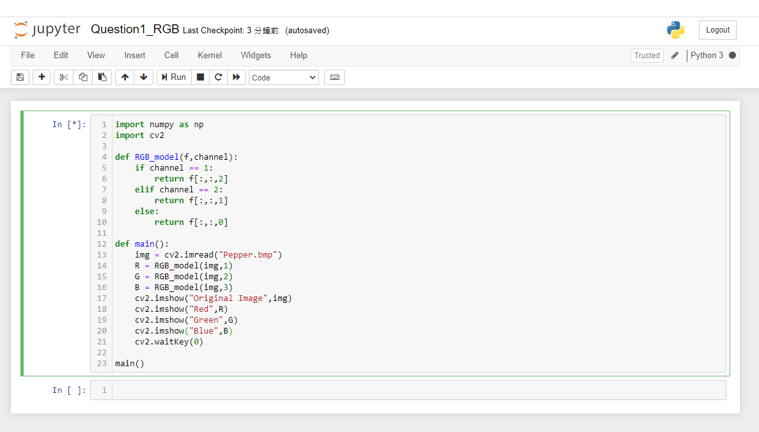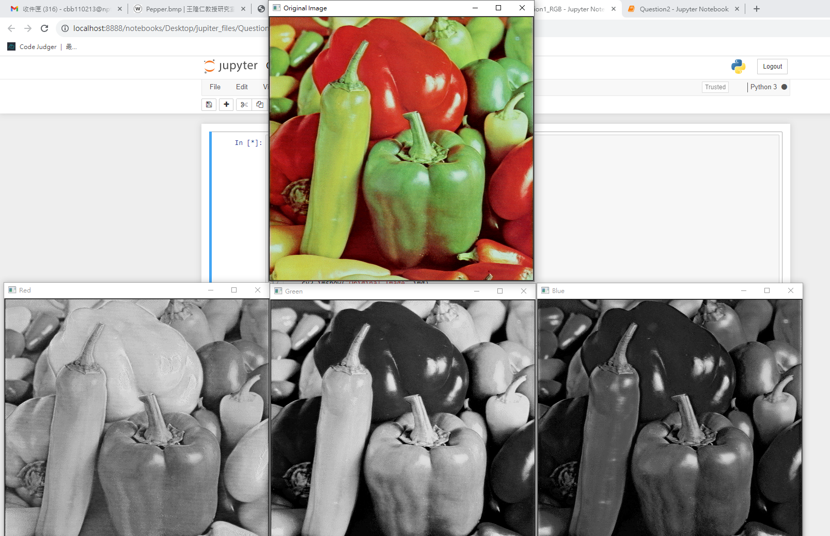

CMY MODEL:

import numpy as np

import cv2

def CMY_model(f,channel):

if channel == 1:

return 255 - f[:,:,2]

elif channel == 2:

return 255 - f[:,:,1]

else:

return 255 - f[:,:,0]

def main():

img = cv2.imread("Pepper.bmp",-1)

C = CMY_model(img,1)

M = CMY_model(img,2)

Y = CMY_model(img,3)

cv2.imshow("Original Image",img)

cv2.imshow("Cyan",C)

cv2.imshow("Magenta",M)

cv2.imshow("Yellow",Y)

cv2.waitKey(0)

main()

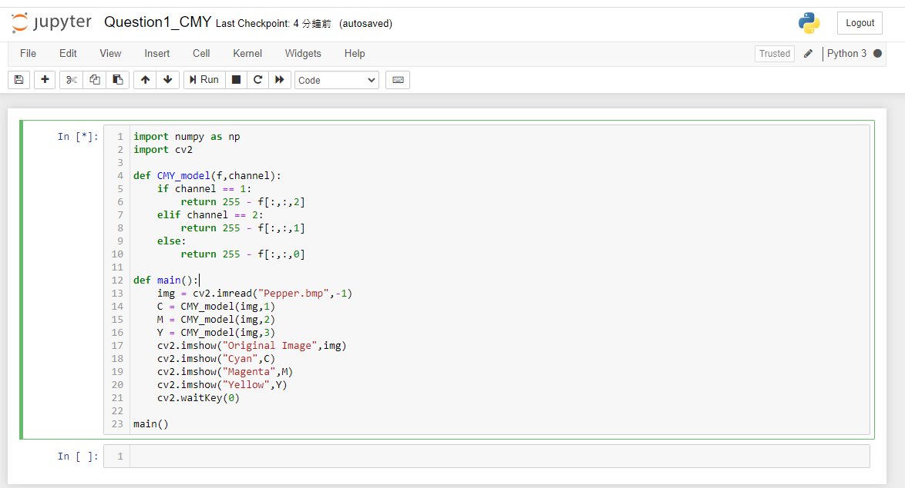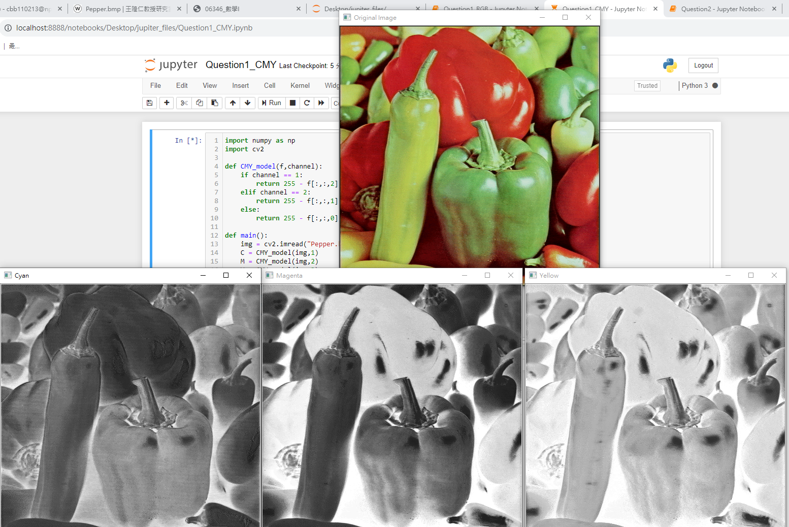

HSI MODEL:

import numpy as np

import cv2

def RGB_to_HSI(R,G,B):

r = R/255

g = G/255

b = B/255

if R==G and G==B:

H = -1.0

S = 0.0

I = (r+g+b)/3

else:

x = (0.5*((r-g)+(r-b)))/\

np.sqrt((r-g)**2+(r-b)*(g-b))

if x<-1.0: x=-1.0

if x>1.0: x=1.0

theta = np.arccos(x)*180/np.pi

if B<=G:

H = theta

else:

H = 360.0-theta

S=1.0-3.0/(r+g+b)*min(r,g,b)

I = (r+g+b)/3

return H,S,I

def HSI_model(f,channel):

nr,nc = f.shape[:2]

g = np.zeros([nr,nc],dtype='uint8')

if channel == 1:

for x in range(nr):

for y in range(nc):

H,S,I = RGB_to_HSI(f[x,y,2],f[x,y,1],f[x,y,0])

if H==-1:

k=0

else:

k=round(H*255/360)

g[x,y]=np.uint8(k)

elif channel == 2:

for x in range(nr):

for y in range(nc):

H,S,I = RGB_to_HSI(f[x,y,2],f[x,y,1],f[x,y,0])

k = round(S*255)

g[x,y] = np.uint8(k)

else:

for x in range(nr):

for y in range(nc):

H,S,I = RGB_to_HSI(f[x,y,2],f[x,y,1],f[x,y,0])

k = round(I*255)

g[x,y] = np.uint8(k)

return g

def main():

img = cv2.imread("Pepper.bmp",-1)

H = HSI_model(img,1)

S = HSI_model(img,2)

I = HSI_model(img,3)

cv2.imshow("Original Image",img)

cv2.imshow("Hue",H)

cv2.imshow("Saturation",S)

cv2.imshow("Intensity",I)

cv2.waitKey(0)

main()

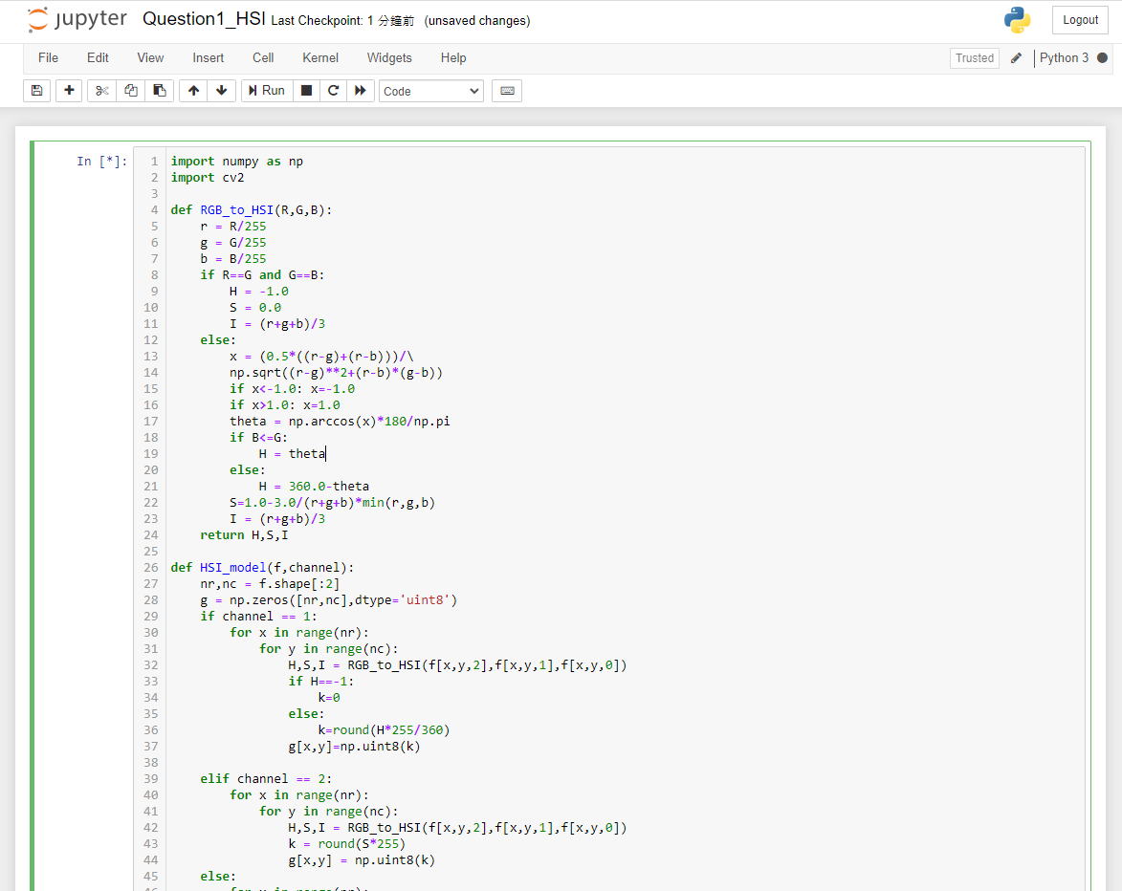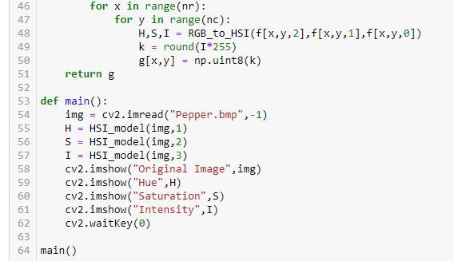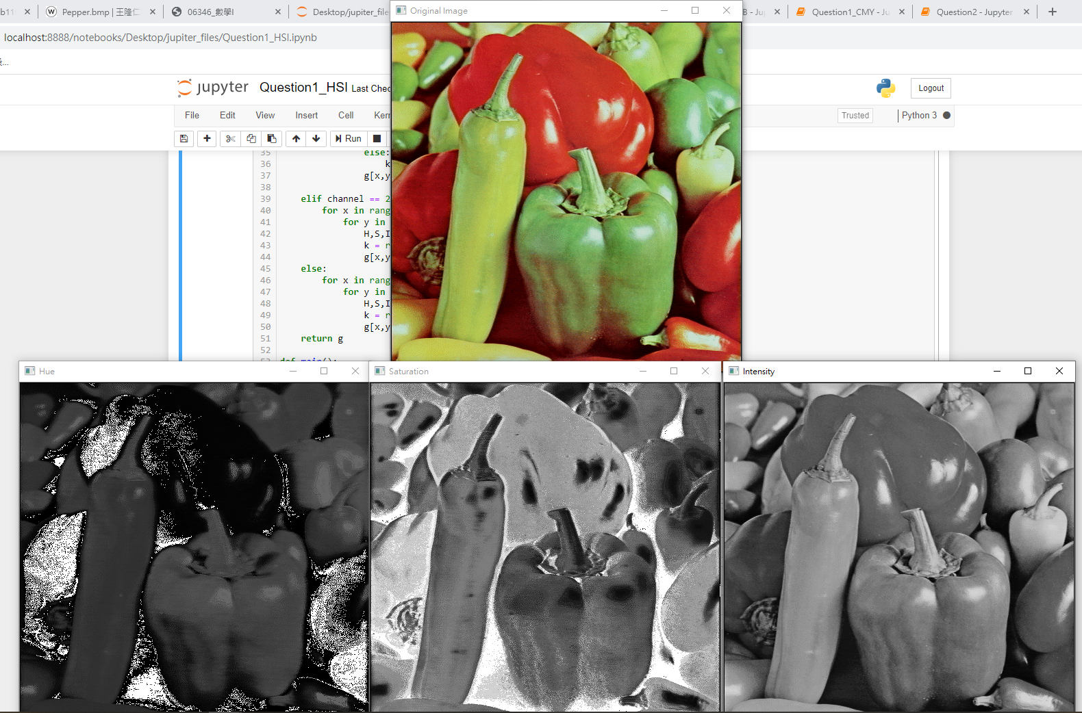

HSV MODEL:

import numpy as np

import cv2

def HSV_model(f,channel):

hsv = cv2.cvtColor(f,cv2.COLOR_BGR2HSV)

if channel == 1:

return hsv[:,:,0]

elif channel == 2:

return hsv[:,:,1]

else:

return hsv[:,:,2]

def main():

img = cv2.imread("Pepper.bmp",-1)

H = HSV_model(img,1)

S = HSV_model(img,2)

V = HSV_model(img,3)

cv2.imshow("Original Image",img)

cv2.imshow("Hue",H)

cv2.imshow("Saturation",S)

cv2.imshow("Value",V)

cv2.waitKey(0)

main()

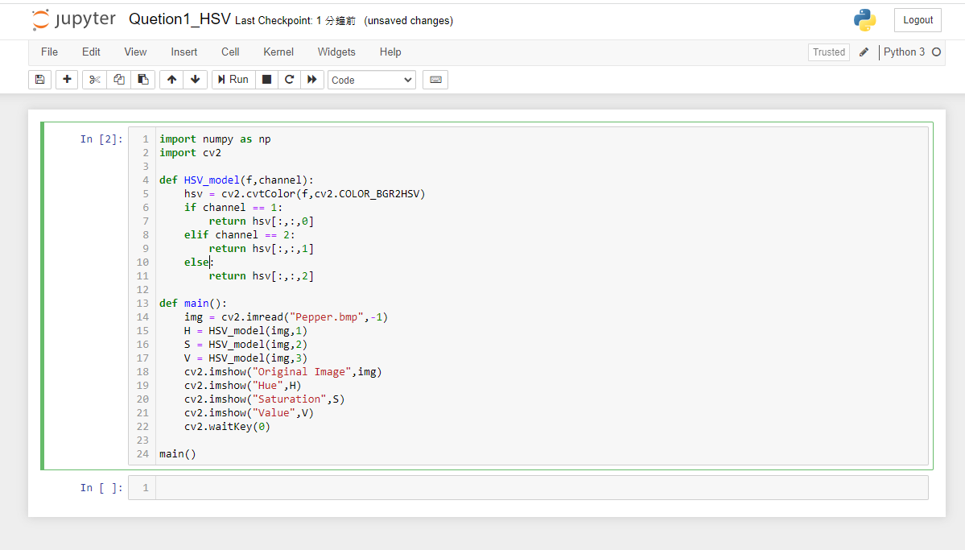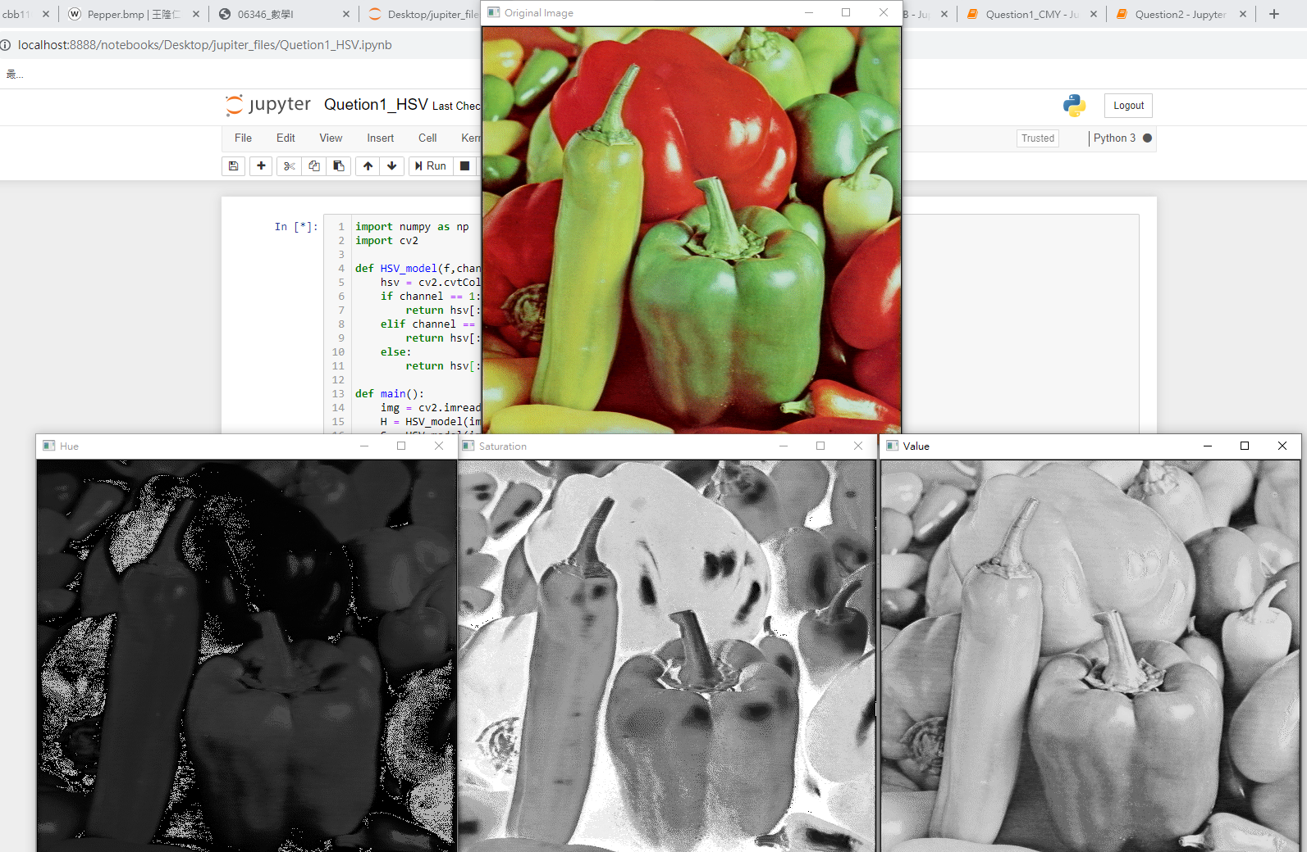

YCrCb:

import numpy as np

import cv2

def YCrCb_model(f,channel):

ycrcb = cv2.cvtColor(f,cv2.COLOR_BGR2YCrCb)

if channel == 1:

return ycrcb[:,:,0]

elif channel == 2:

return ycrcb[:,:,1]

else:

return ycrcb[:,:,2]

def main():

img = cv2.imread("Pepper.bmp",-1)

Y = YCrCb_model(img,1)

Cr = YCrCb_model(img,2)

Cb = YCrCb_model(img,3)

cv2.imshow("Original Image",img)

cv2.imshow("Y",Y)

cv2.imshow("Cr",Cr)

cv2.imshow("Cb",Cb)

cv2.waitKey(0)

main()

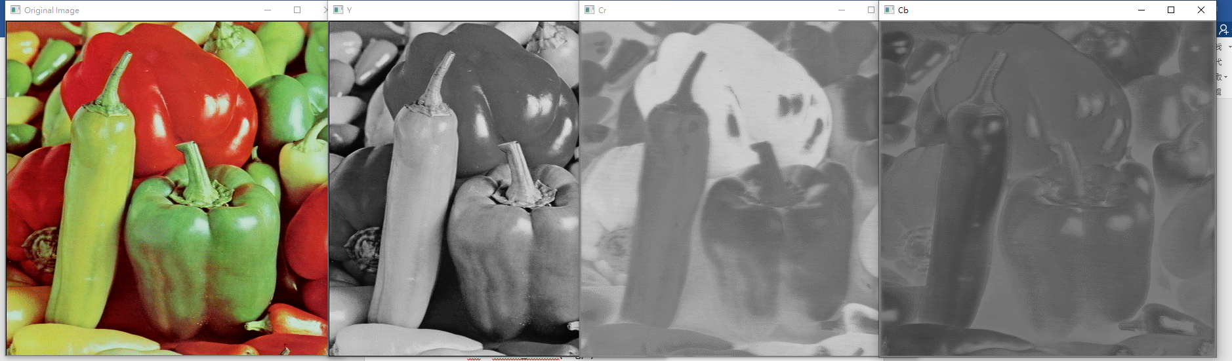

第二題:

import numpy as np

import cv2

import pywt

def DWT_image(f,wavelet):

nr,nc = f.shape[:2]

coeffs = pywt.dwt2(f,wavelet)

LL,(LH,HL,HH) = coeffs

nr1,nc1 = LL.shape[:2]

g = np.zeros([nr1*2,nc1*2],dtype='uint8')

LL_normalized = np.zeros([nr1,nc1])

cv2.normalize(LL,LL_normalized,0,255,cv2.NORM_MINMAX)

g[0:nr1,0:nc1] = np.uint8(LL_normalized[:,:])

return g

def IDWT_image(LL, wavelet):

coeffs = LL, (None, None, None)

img = pywt.idwt2(coeffs, wavelet)

return np.uint8(img)

def PSNR(f,g):

nr,nc = f.shape[:2]

MSE = 0.0

for x in range(nr):

for y in range(nc):

MSE+=(float(f[x,y])-float(g[x,y]))**2

MSE/=(nr*nc)

PSNR = 10*np.log10((255*255)/MSE)

return PSNR

def main():

img1 = cv2.imread("House.bmp",-1)

img2 = DWT_image(img1,'db1')

reconstructed_img = IDWT_image(img2,'db1')

cv2.imshow("Original Image",img1)

cv2.imshow("Discrete Wavelet Transform",img2)

cv2.imshow("Reconstructed Image",reconstructed_img)

print("The PSNR = ",PSNR(img1,reconstructed_img))

cv2.waitKey(0)

main()

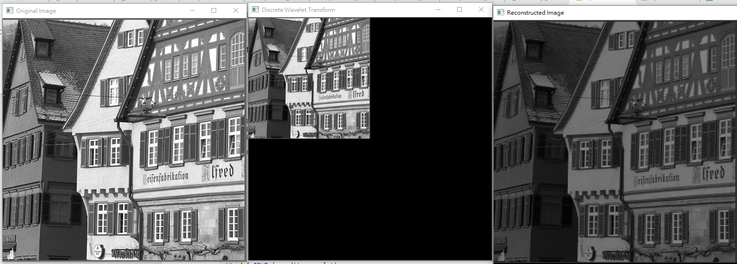

第三題:

import numpy as np

import cv2

def entropy(f):

nr,nc = f.shape[:2]

pdf = np.zeros(256)

for x in range(nr):

for y in range(nc):

pdf[f[x,y]]+=1

pdf/=(nr*nc)

H=0

for k in range(256):

if pdf[k]!=0:

H+=(-pdf[k]*np.log2(pdf[k]))

return H

def main():

img1 = cv2.imread("Barbara.bmp",-1);

img2 = cv2.imread("Osaka.bmp",-1);

cv2.imshow("Barbara.bmp",img1)

cv2.imshow("Osaka.bmp",img2)

H1 = entropy(img1);

H2 = entropy(img2);

print("Barbara's Entropy = ",H1)

print("Osaka's Entropy = ",H2)

cv2.waitKey(0)

main()

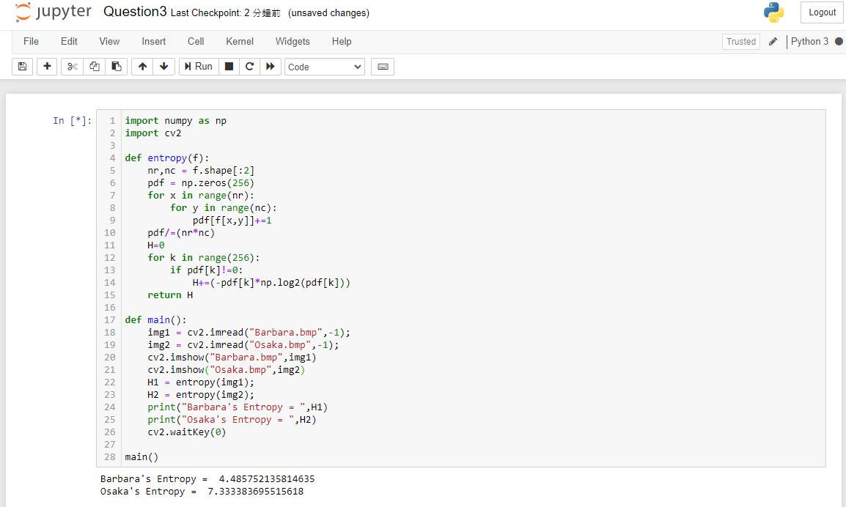

第四題:

CNN:

from keras.models import Sequential

from keras.layers.core import Dense, Dropout

from keras.layers import Conv2D, MaxPooling2D, Flatten

from keras.utils import np_utils

from keras.datasets import mnist

def load_data():

(x_train,y_train),(x_test,y_test) = mnist.load_data()

number = 1000

x_train = x_train[0:number]

y_train = y_train[0:number]

x_train = x_train.reshape(number,28,28,1)

x_test = x_test.reshape(x_test.shape[0],28,28,1)

x_train = x_train.astype('float')

x_test = x_test.astype('float')

y_train = np_utils.to_categorical(y_train,10)

y_test = np_utils.to_categorical(y_test,10)

return (x_train,y_train),(x_test,y_test)

(x_train,y_train),(x_test,y_test)=load_data()

model = Sequential()

model.add(Conv2D(30,(3,3),padding = 'same',input_shape = (28,28,1),activation = 'relu'))

model.add(MaxPooling2D(pool_size=(2,2)))

model.add(Conv2D(30,(3,3),padding='same',activation = 'relu'))

model.add(MaxPooling2D(pool_size=(2,2)))

model.add(Flatten())

model.add(Dense(units=200,activation='relu'))

model.add(Dense(units=10,activation='softmax'))

model.compile(loss='categorical_crossentropy',optimizer='adam',metrics=['accuracy'])

model.fit(x_train,y_train,batch_size=100,epochs=100,validation_data=(x_test,y_test),shuffle=True)

result - models.evaluate(x_test,y_test)

print('\n Test Acc:',result[1])

y_pred = model.predict(x_test)

y_pred_class = model.predict_classes(x_test)

ANN:

from keras.datasets import mnist

from keras.models import Sequential

from keras.layers import Dense

from keras.utils import to_categorical

(train_images,train_labels),(test_images,test_labels) = mnist.load_data()

network = Sequential()

network.add(Dense(512,activation='relu',input_shape=(784,)))

network.add(Dense(10,activation='softmax'))

network.compile(optimizer = 'rmsprop',loss = 'categorical_crossentropy',metrics = ['accuracy'])

print(network.summary())

train_images = train_images.reshape((60000,28*28))

train_images = train_images.astype('float32')/255

test_images = test_images.reshape((10000,28*28))

test_images = test_images.astype('float32')/255

train_labels = to_categorical(train_labels)

test_labels = to_categorical(test_labels)

network.fit(train_images,train_labels,epochs = 5, batch_size=200)

test_loss,test_acc = network.evaluate(test_images,test_labels)

print("Test Accuracy:",test_acc)

CNN:

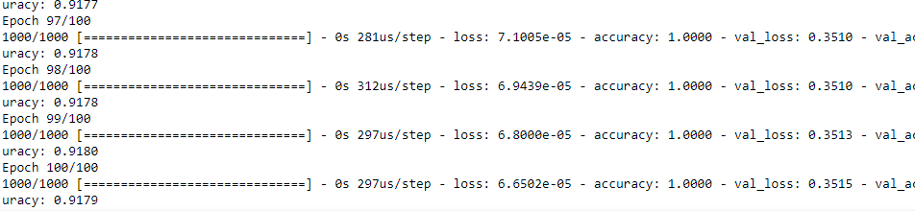

ANN:

